Name:______________________________________

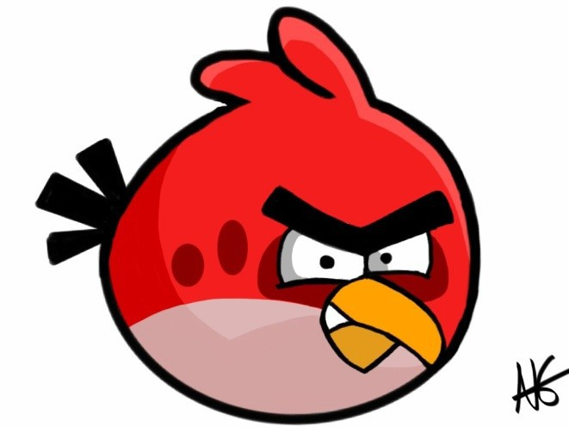
❖ Feeling angry is ok!

I feel angry when ………………………………
……………………………………………………………….
……………………………………………………………….
……………………………………………………………….
………………………………………………………………

(episode one)  IT’S NOT FAIR!  (STOP AND THINK!) (anger can be scary…) | Questions to think about:  - What makes it hard sometimes to Stop and Think?  …………………………………………………………………………………………………………………………………  2. How did ‘Stop and Think’ help Jimmy make Steve play fair?  We can’t control our feelings, but we can control our acts!!!  ……………………………………………………………………………………………………………………………………
(episode two)  EVERYBODY BOSSES ME AROUND!  (TALK ABOUT HOW YOU FEEL!)  (anger can be uncomfortable…) | Questions to think about:  - How did talking about her angry feelings help Lisa?  ……………………………………………………………………………………………………………………………………  - Who do you like to talk to when you’re angry?  ……………………………………………………………………………………………………………………………………
(episode three)  YOU KNOW WHY I’M MAD!  (PEOPLE MAY NOT KNOW WHY YOU’RE ANGRY ABOUT) (anger can make you do things you didn’t mean to…) | Questions to think about:  1. Jennifer was sure her friend knew why she was angry, but the  friend didn’t! Why not?  ……………………………………………………………………………………………………………………………………  2. Has anything like this ever happened to you? What did you do  about it?  ……………………………………………………………………………………………………………………………………
(episode four)  WHEN ANGER EQUALS ENERGY!  (…but anger can give you energy and make you try harder!) | Questions to think about:  1. This program tells you some things you can do when you’re angry.  What are they?  ……………………………………………………………………………………………………………………………………  - What are some other things you could do?  ……………………………………………………………………………………………………………………………………

